COM2001: Advanced Programming Topics

Assignment 2

**Design**

**Data Types**

In this assignment, four new data types are introduced.

**1. DomsPlayer:** Represent a player function

type DomsPlayer = Hand -> Board -> (Domino, End)

**2. Turn:** An algebraic data type to represent a turn for Player 1 or Player 2

data Turn = P1 | P2 deriving (Eq,Show)

**3. Hands:** Use a tuple to represent a pair of hands, i.e. Player 1’s hand and Player 2’s hand

type Hands = (Hand, Hand)

**4. Scores:** Use a tuple for Player 1’s score and Player 2’s score

type Scores = (Int, Int)

Variable names used in this document**:**

**dom :** A domino

**brd :** A board

**end, L, R :** An end, Left or Right

**hand** : A hand of a player

**hands :** A pair of hands

**p1, p2 :** Player 1 and Player 2

**score :** The score after playing a domino

**seed :** An integer used to initialise the random number generator

**Functions**

**1. simplePlayer:** It will be a recursive function, which calls itself until the first domino in its hand can be played

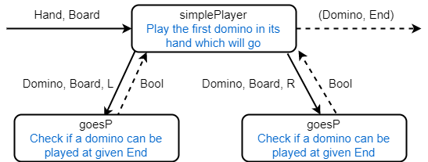

**Figure 1. Design of simplePlayer**

**Steps:** 1. Call **simplePlayer** **(dom:rhand) brd**

2. If the first **dom** can be played at **L**, then return **(dom, L)**

3. Else if the first **dom** can be played at **R**, then return **(dom, R)**

4. Otherwise call **simplePlayer rhand brd**

**2. hsdPlayer:** It will use helper functions to find the maximum scoring domino played at **L**, and the maximum scoring domino played at **R**, then compare and return the maximum between the two dominoes

**2.1. maxHsd**

**Steps**: 1. Compare the dominoes returned by **hsdLeft** and **hsdRight**

2. Return the maximum domino as **(score, dom, end**)

**2.2. hsdLeft**

**Steps**: 1. Play all dominoes that can be played at **L**

2. Use **scoreboard** function to calculate the score of each domino

3. Use **maximum** function to find the maximum domino

4. Return the maximum domino as **(score, dom, L)**

**2.3. hsdRight**

**Steps**: 1. Play all dominoes that can be played at **R**

2. Use **scoreboard** function to calculate the score of each domino

3. Use **maximum** function to find the maximum domino

4. Return the maximum domino as **(score, dom, R)**

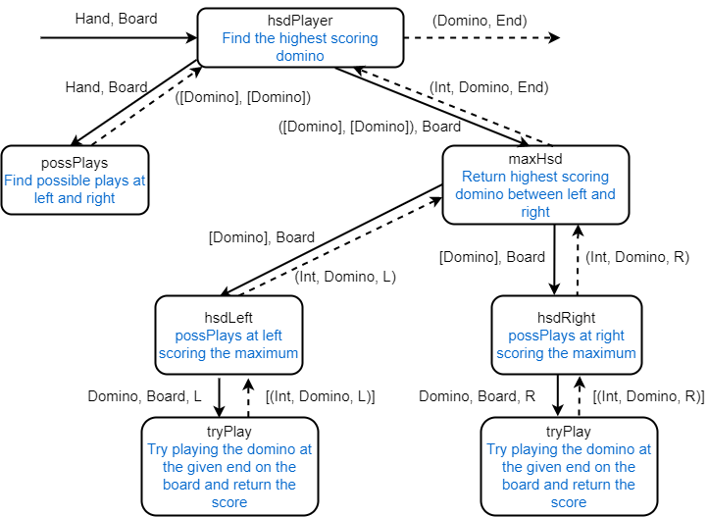

**Figure 2. Design of hsdPlayer**

**Steps:** 1. Call **hsdPlayer hand brd**

2. **hsdPlayer** will call **possPlays** **hand brd** to return the possible plays for **L** and **R**

3. Call **maxHsd hands brd,** which the **hands** are the tuple of list of dominoes returned by **possPlays**

4. **maxHsd** will call **hsdLeft** and **hsdRight**, and use **max** function to find the maximum domino

5. **hsdLeft** and **hsdRight** will return the maximum domino played at **L** and **R** respectively, as mentioned in **2.2** and **2.3** above

**3. shuffleDoms:** Provide a seed, and it will generate a full list of dominoes in random order

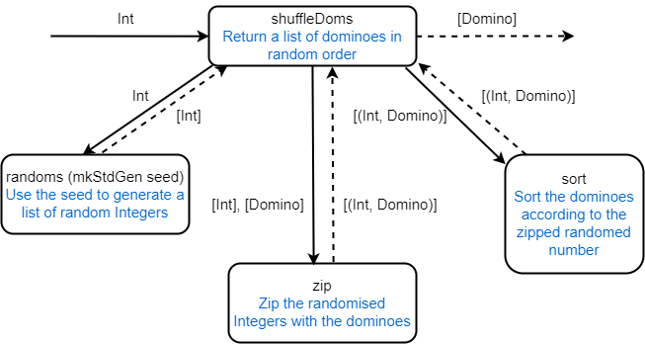

**Figure 3. Design of shuffleDoms**

**Steps:** 1. Call **shuffleDoms seed**

2. Use **randoms** and **mkStdGen** to generate a list of random integers

3. **Zip** the list of integers with the full dominoes set

4. **Sort** the list, and then return the list with the generated number removed

**4. playDomsRound:** Given two players (**simplePlayer** or **hsdPlayer**), return the final score of each player in pair

**4.1. createHands:** Simply take the first 9 dominoes as **Player 1’s** hand, and the next 9 dominoes as **Player 2**’s hand

**4.2. startTurn**

**Steps**: 1. If **endGame** returns true, then return the final score

2. Else if **p1CanPlay** returns true, then call **p1Turn**

3. Else if **p2CanPlay** returns true, then call **p2Turn**

4. Call **startTurn** again until **endGame** returns true

**4.3. endGame:** If **Player 1** and **Player 2** are **knocking**, then returns true.

**4.4. p1CanPlay:** Return **True** if it is **Player 1’s** turn and **Player 1** is **not knocking**, or **Player 2** is **knocking**

**4.5. p2CanPlay:** Return **True** if it is **Player 2’s** turn and **Player 2** is **not knocking**, or **Player 1** is **knocking**

**4.6. playerPlay:** Make a single move, returning the resulting hand and board, and the score for that move

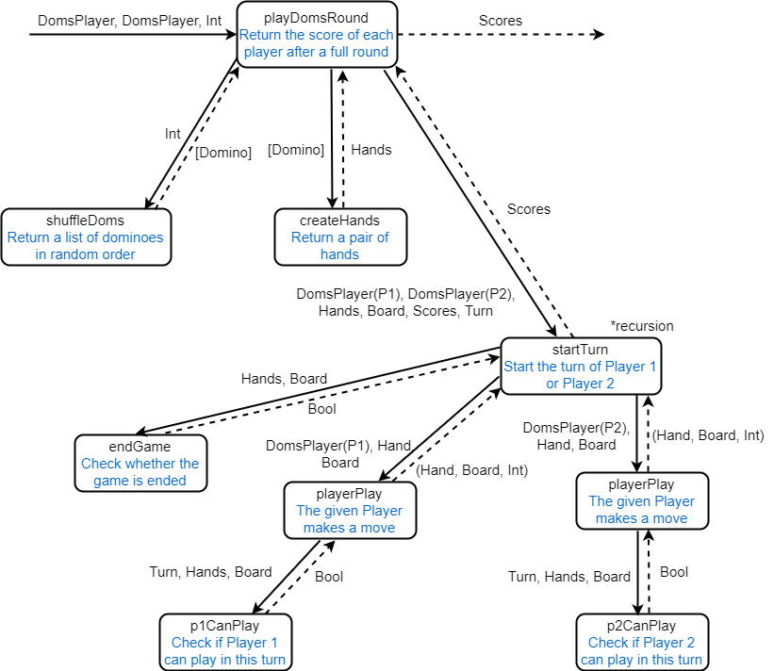

**Figure 4. Design of playDomsRound**

**Steps:** 1. Call **playDomsRound p1 p2 seed**

2. **shuffleDoms** will be called, then **createHands** will be called next.

3. After that, **startTurn** will be called, given **[], (0,0), P1** as starting value for the **Board, Scores, Player**

4. **startTurn** will be called recursively until **endGame** returns **True,** as mentioned in **4.2** above. Then it will return the final score back to **playDomsRound**